# ABSTRACT

Nowadays, boarding schools or colleges uses outing book for the hostel students to go outing. Before they go outing, they need to fill in the book and the hostel administration needs to put a stamp on it as an approval. The existing hostel outing system requires tedious process, manual efforts and it is also time consuming.

To overcome these problems, we have developed a web-based system, which can help both the hostel administration and the students. This application allows the students to apply the outing online and the hostel administration gives the approvals through online there by eliminating the manual process. After returning, the details are updated in the system so that the complete outing history of the student can be accessible at any time.

Figure 2.1: Waterfall Model 4

Figure 2.2: Context Diagram of the system 5

Figure 2.3: Data Flow Diagram 6

Figure 2.4: Entity-Relationship Diagram (ERD) of the system 7

Figure 2.5: Data Base Table HYPERLINK "file:///C:/Users/Lenovo/Downloads/B1%20Report%20(1).docx"…………………………………………

……………………………. HYPERLINK "file:///C:/Users/Lenovo/Downloads/B1%20Report%20(1).docx".. HYPERLINK "file:///C:/Users/Lenovo/Downloads/B1%20Report%20(1).docx"7

Figure 2.6: Table warden in the database 8

Figure 2.7: Table student in the database 8

Figure 2.8: Table student details in the database 9

Figure 2.9: Table data details in the database 9

Figure 3.1: Main Page 11

Figure 3.2: About Page 11

Figure 3.3: Applied Module 12

Figure 3.4: User Details Page 13

Figure 3.5: Return Requests Page 14

Figure 3.6: In Date Page 14

Figure 3.7: Student Login page 15

Figure 3.8: Outing Form 15

Figure 3.9: Status Check 16

Figure 3.10: Reports Page 16

Figure 3.11: Date Wise Reports 17

Figure 3.12: Late Reports 17

Figure 3.13: Range Reports 18

Figure 3.14: Contact Details 19

# CHAPTER I INTRODUCTION

* 1. **BACKGROUND**

Outing is a one part of the activity that each college record to know the information of student who going outing. In a manual outing management system, student need stamp on their outing book before go outing. This will require some time to student to get a stamp and warden that need to stamp on it as a permission for student to go outing. To overcome these problems we have developed a web application i.e E-Outing System.

E-Outing system is a system for the college student that can ease the outing management. E- Outing System act as record keeper for warden to analyse the student. E-Outing System also helps warden to monitor outing activity more efficiently compared to manual system. When a student wants to go for outing, they can apply through this online system and after verification; the warden can approve the request or reject the request. This approval status is available in the student login. After returning from outing, the details are updated in the system. This system will help the hostel administration to access the different kinds of reports at any time.

# System Requirements Specification

* + 1. **Software Requirements**
       - Hypertext Mark-up Language (HTML)
       - Cascading Style Sheets (CSS)
       - PHP
       - Java script
       - MySQL database
* Apache

# Hardware Requirements

* + - * Operating System: Microsoft windows 7 or above.
      * Processor : Intel core i5/i7
      * RAM : 8+ GB
      * Space on hard disk: 1TB

# PROBLEM STATEMENT

Many of the boarding schools/colleges do not have a computerized system in to keep student's outing information. The security staff must record and check manually the outing's information of each student. Based on manual system, students need to write down the name, time or date of outing and need to drop the signature in the log book before going out from hostel. The security staff needs to record the entire outing's information of the student for many times.

Manual record system is time consuming because the students must write down the name, time or date of outing and need to drop the signature in the log book before going out fi-om hostel. This may cause the administrator management perforce to update all the files every day. So, this manual process will consume improper time effort and is impractical. Besides that, it is difficult way for administrator management to checking, searching and detecting status of each outing's student because they need to find the information files manually.

# SCOPE FOR USER

Admin (Warden)

* The person who controls this system and update the system based on situation.
* People who responsible to register student and new admin.

Student (Hostel Student)

* User need to log in to the system first. Next, add the outing activity before they go for outing.
* User also able to view approval from warden in this system

# SCOPE FOR SYSTEM

* Login -There is login to enter this system based on type of user
* Add outing activity -Student can apply their outing activity before go for outing.
* Manage staff -Admin can add new warden for this system.
* Manage outing information -Admin will update the information of outing.
* View report -Admin able to view the report outing activity of each student

# CHAPTER 2 METHODOLOGY

* 1. **INTRODUCTION**

This chapter explains the methodology design that being applied in the software development. Boarding School Outing Management System will undergo some phases from the beginning until project submission. In this chapter, the modelling and design is also being explained to give the overall view on how this system including database works. The modelling and design is shown by the Entity Relationship Diagram (ERD), context diagram and Data Flow Diagram, which are provided in this chapter. Besides, this chapter also explain the model of methodology that able help developer manage project efficiently and able to achieve objective and scope of this project.

# JUSTIFICATION SELECTION

For this proposed system, we use Software Development Life Cycle which is Waterfall Model[3]. Waterfall model has been widely used for system development life cycle to create a system with a linear and sequential approach. There are many advantages of using Waterfall Model because it is very simple to understand and use.

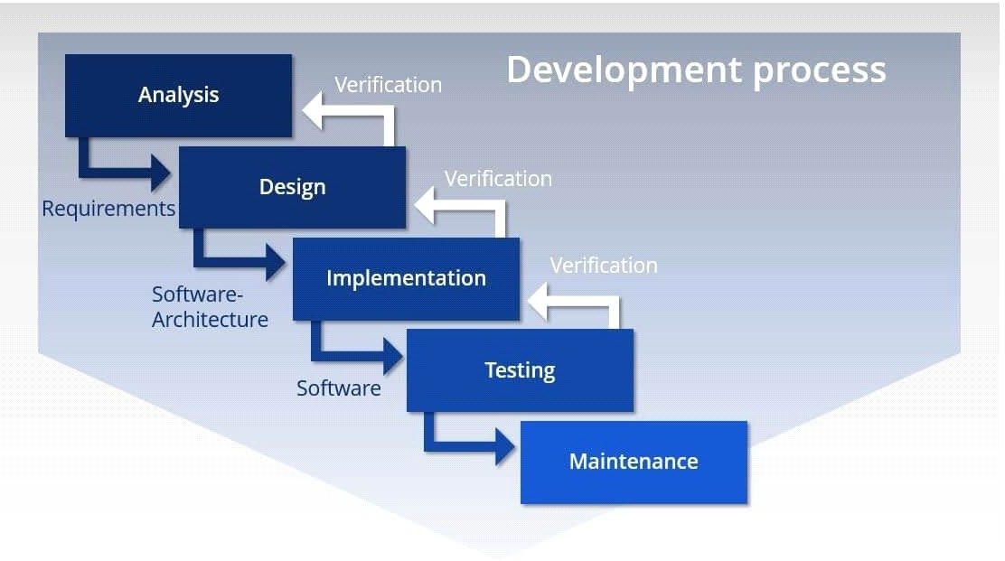

***Figure 2.1: Waterfall Model***

# PROJECT METHODOLOGY

In **E-OUTING SYSTEM**, Waterfall Model has been chosen as a methodology. There are six phase that involved in the waterfall model that include requirement gathering and analysis, System design, Implementation, Testing, Deployment of system and maintenance.

**Requirement Analysis:** The phase starts with brainstorming the ideas of current problem and system request. Besides, meet up with user to know the detail requirement for this system. In this phase also, the requirement gathering is been discuss with supervisor to conclude the requirement suitable for the system.

**System Design:** The requirement specifications from first phase are studied in this phase and the system design is prepared. This system design helps in specifying hardware and system requirements and helps in defining the overall system architecture.

**Implementation:** The inputs from the system design are converted, to small program called unit in first developed then it will have integrated in the next phase. Each unit is developed and tested for its functionality, which is referred to as Unit Testing.

**Testing:** All the unit in implementation phase are integrated into system after testing of each unit. Any change of coding, error, functionality or upgrades are also will be tested. User Interface will be checked to ensure they are connected to database and appropriate with the system.

**Deployment of System** Once the functional and non-functional testing is done; the product is deployed in the customer environment or released into the market.

**Maintenance** After the system deploy in the customer environment, there will be some issue arise. To fix those issue patches are released to enhance the functionality of the system to better version.

# CONTEXT DIAGRAM

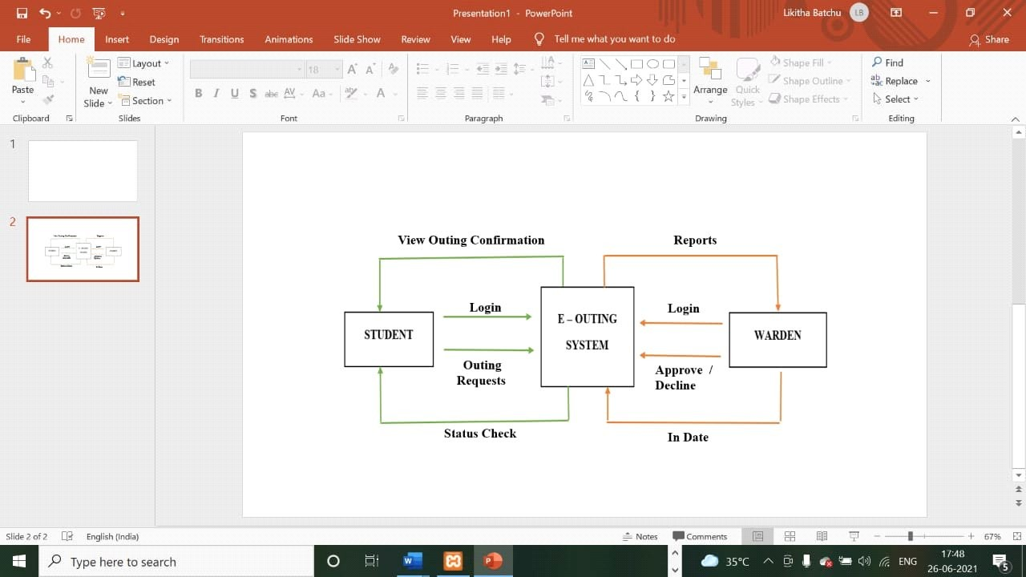

***Figure 2.2: Context Diagram of the system***

Figure 2.2 Show the data flow in E-Outing System. There are two main users which is student and warden. This diagram shows the data flow involving those two main users. Users are required to login to access the system.

# DATA FLOW DIAGRAM (DFD)

* + 1. **DATA FLOW DIAGRAM LEVEL 0**

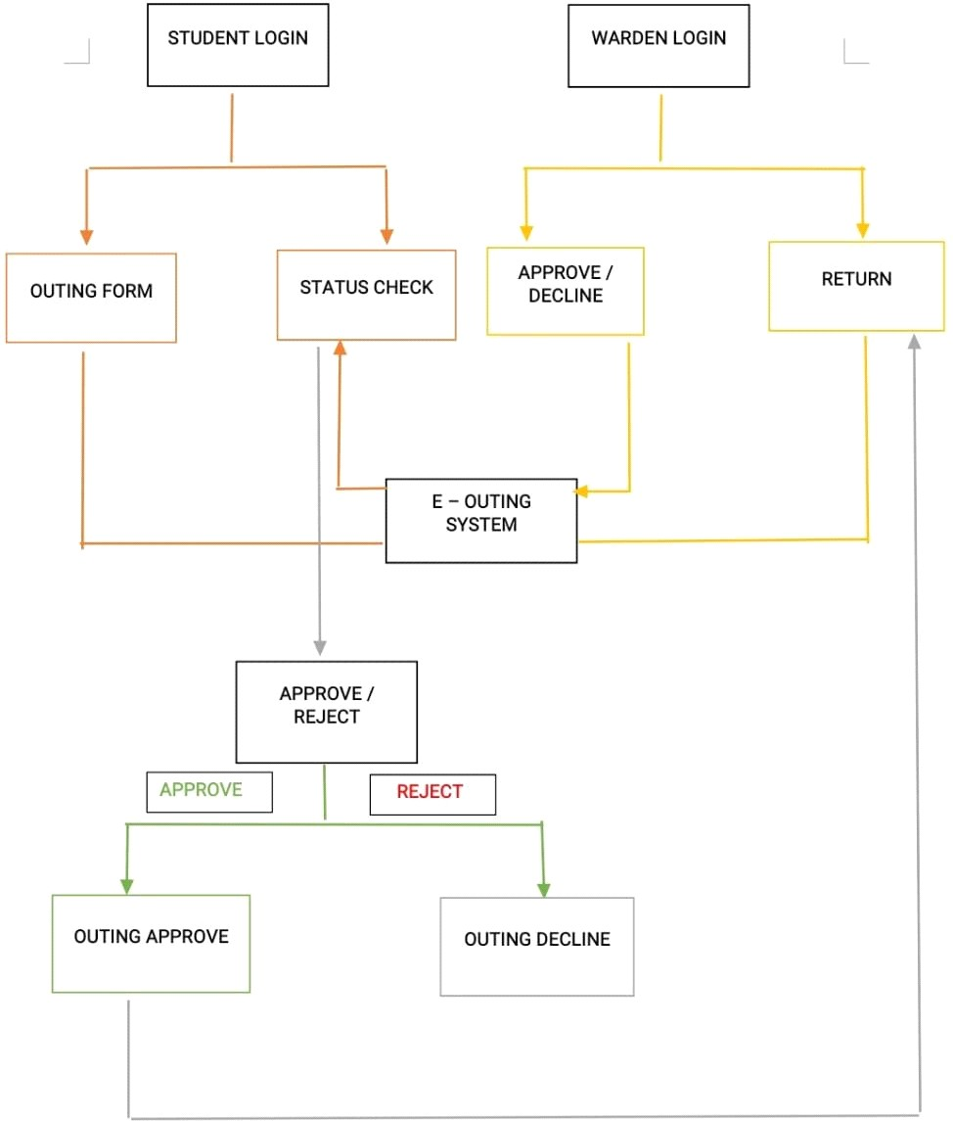

***Figure 2.3: Data Flow Diagram***

According to the DFD in Figure 2.3 above, there are two main entities; WARDEN and STUDENT. The process of the system is LOGIN, MANAGE OUTING, and MANAGE REPORT. Next, the data stores for the E-OUTING System are WARDEN, STUDENT, OUTING and REPORT.

**Process 1.0: Login:** In Login process, WARDEN and STUDENT input LOGIN DETAIL into LOGIN process.

**Process 2.0: Manage Outing:** In Manage Outing process, STUDENT input REQUEST OUTING into MANAGE OUTING process. Then, MANAGE OUTING process will output OUTING RECORD into data store OUTING, invoke OUTING RECORD into MANAGE OUTING and MANAGE OUTING process output OUTING RECORD to WARDEN and WARDEN will output OUTING CONFIRMATION and the OUTING RECORD is input into OUTING data store again.

**Process 3.0: Manage Report:** In Manage Report process, STUDENT data store input STUDENT RECORD, and OUTING data store will input OUTING RECORD into MANAGE REPORT process and output REPORT RECORD to WARDEN entity.

# Entity Relationship Diagram(ERD)

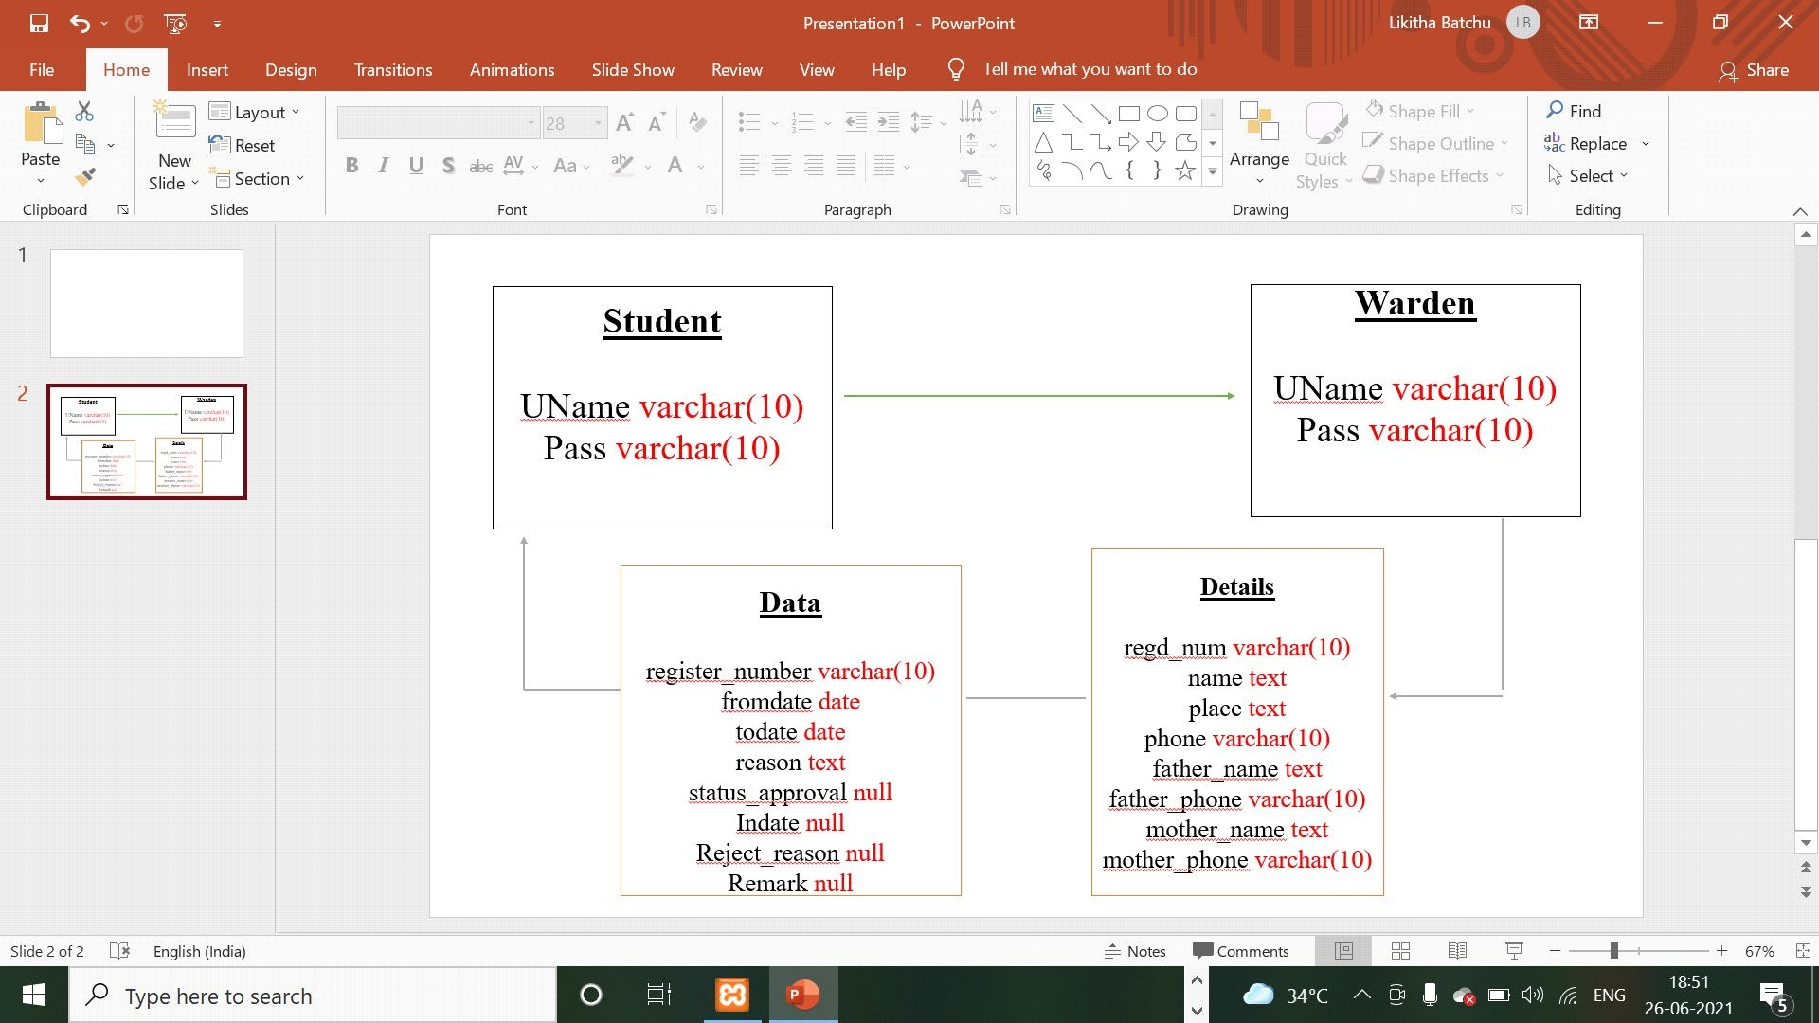

***Figure 2.4: Entity-Relationship Diagram (ERD) of the system***

Figure 2.4 Shows the entities relationship from one table to another table. There are three tables in the ERD above which is STUDENT, WARDEN and OUTING.

* 1. 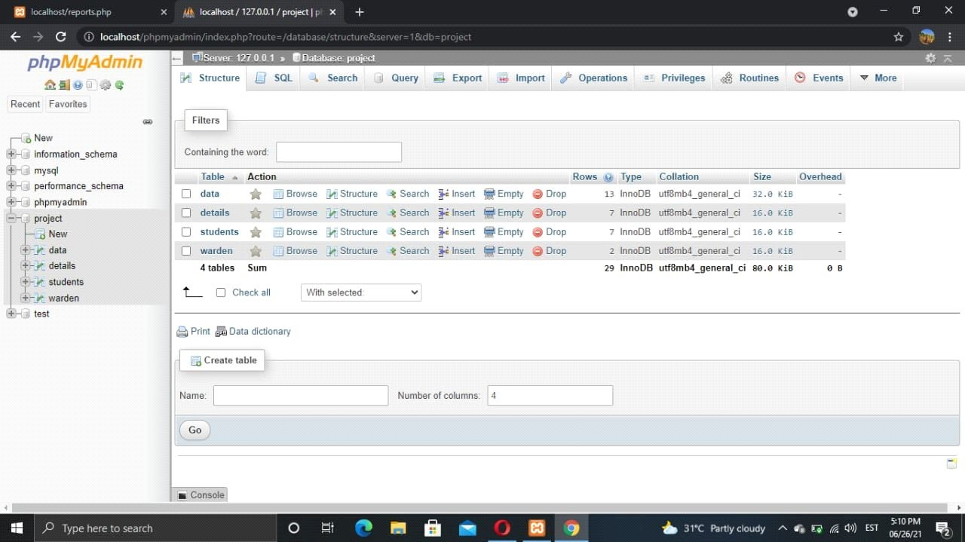

# Database Design

***Figure 2.5: Data Base Table***

Figure 2.5 Shows the tables contained in the database of the system. The database is named as project. There is table outing, parent, student and warden.

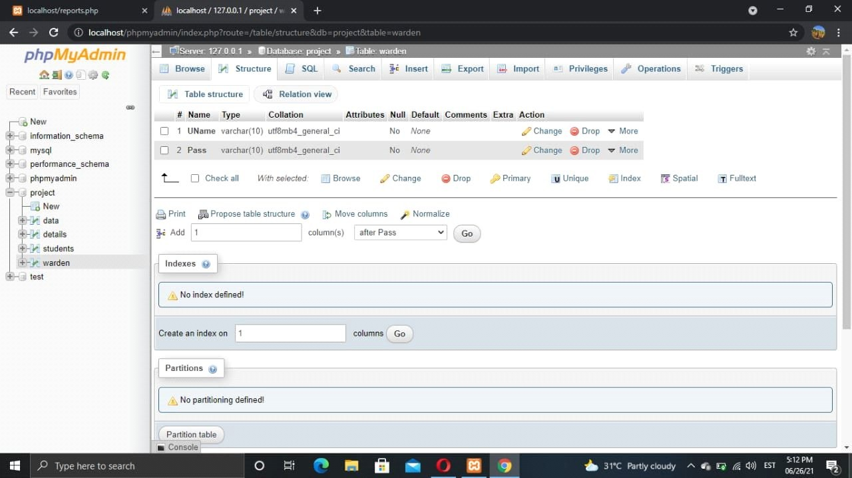

***Figure 2.6: Table warden in the database***

Figure 2.6 Shows the table warden in the database. The table contains warden_id and password. All the data entered by admin will be stored in this table.

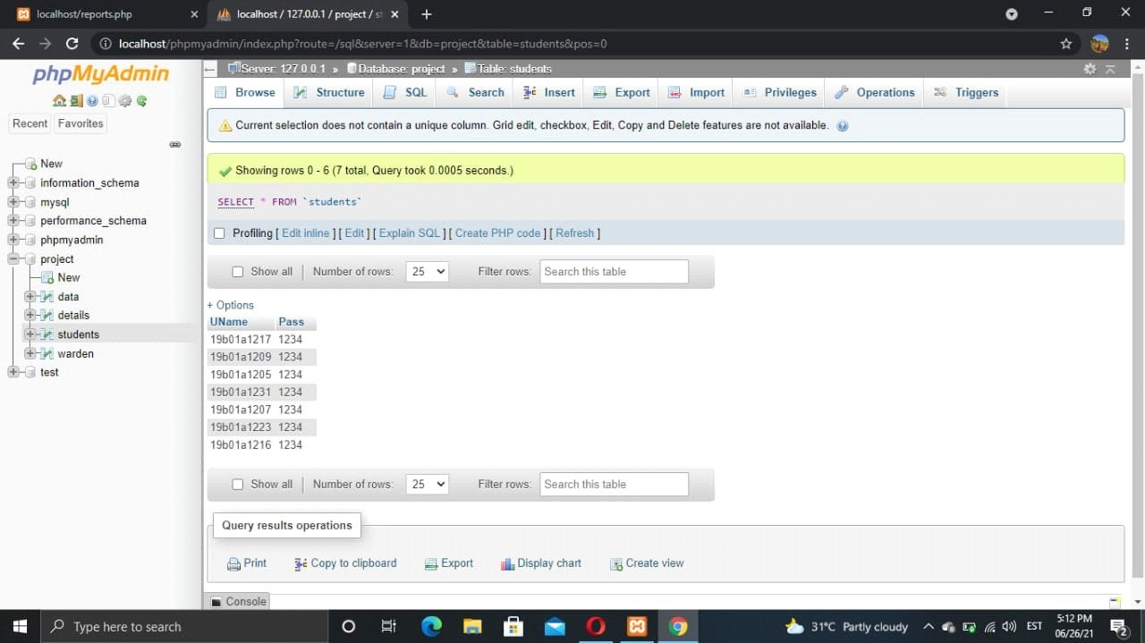

***Figure 2.7: Table student in the database***

Figure 2.7 Shows the table student in the database. The table contains student username and password for logging in to apply the request.

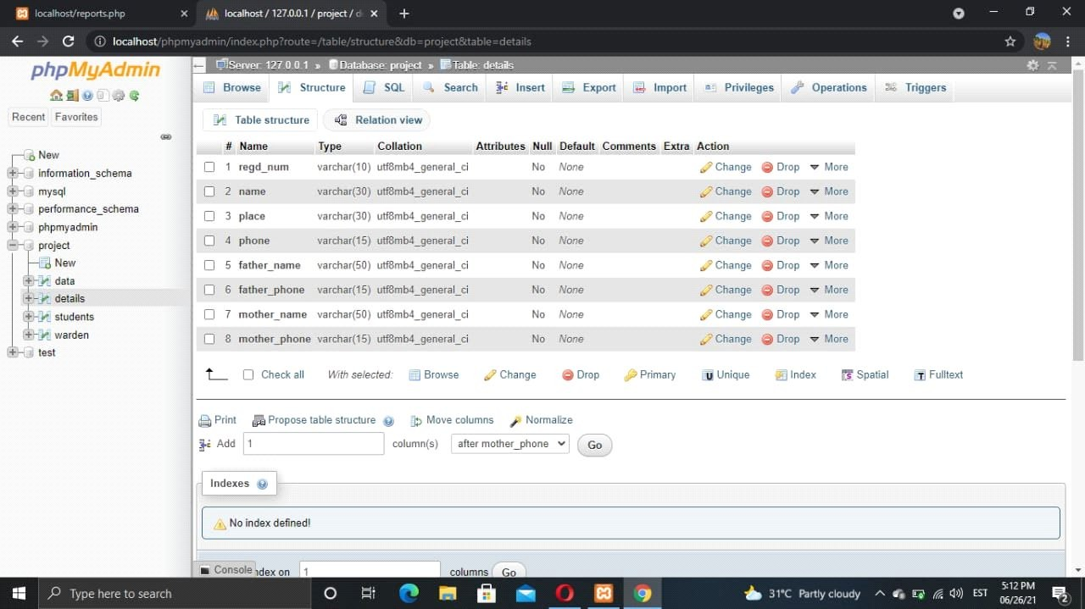

***Figure 2.8: Table student details in the database***

Figure 2.8 Table student details in the database. The table contains student_id, name, phone_number, place, mother_name, mother_phone_number, father_name, father_phone_number. All the data entered by admin.

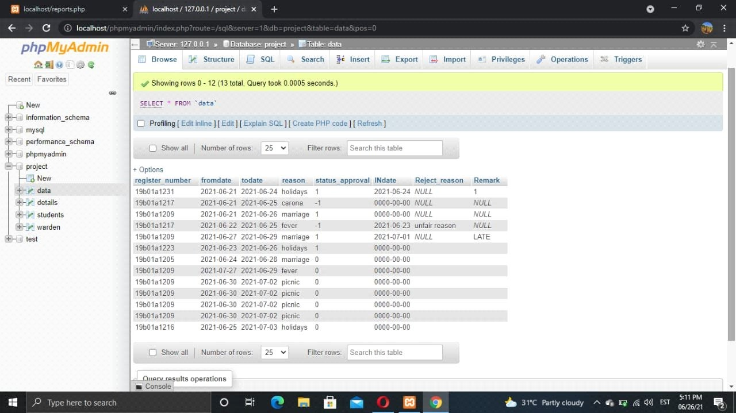

***Figure 2.9: Table data details in the database***

Figure 2.9 Table data in the database. The table contains the information like fromdate, todate, reason that student has applied for outing.

# Conclusion

Every phase is crucial to ensure the development of the proposed system will be implemented correctly. Waterfall model approach is suitable development model to follow with the system development for this proposed system Next, the design methods and system design like context diagram, data flow diagram and entity relationship diagram in this chapter explained the data flow of the system on how the system are working.

# CHAPTER 3

**MODULES**

# INTRODUCTION

System implementation is the construction of the system and the delivery of it into production. Interfaces and user manual of the system are included in this chapter.

# MAIN PAGE

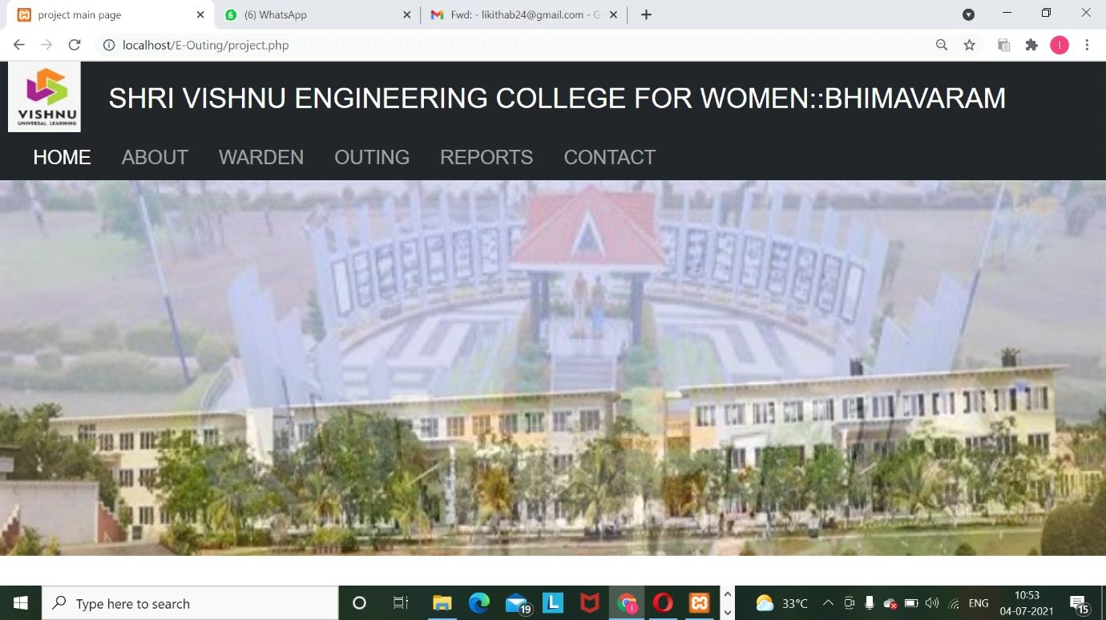

***Fig 3.1: Main Page***

Figure 3.1 Shows the interface of the system. In which it has 5 modules they are about, warden, outing, reports, contact.

# ABOUT

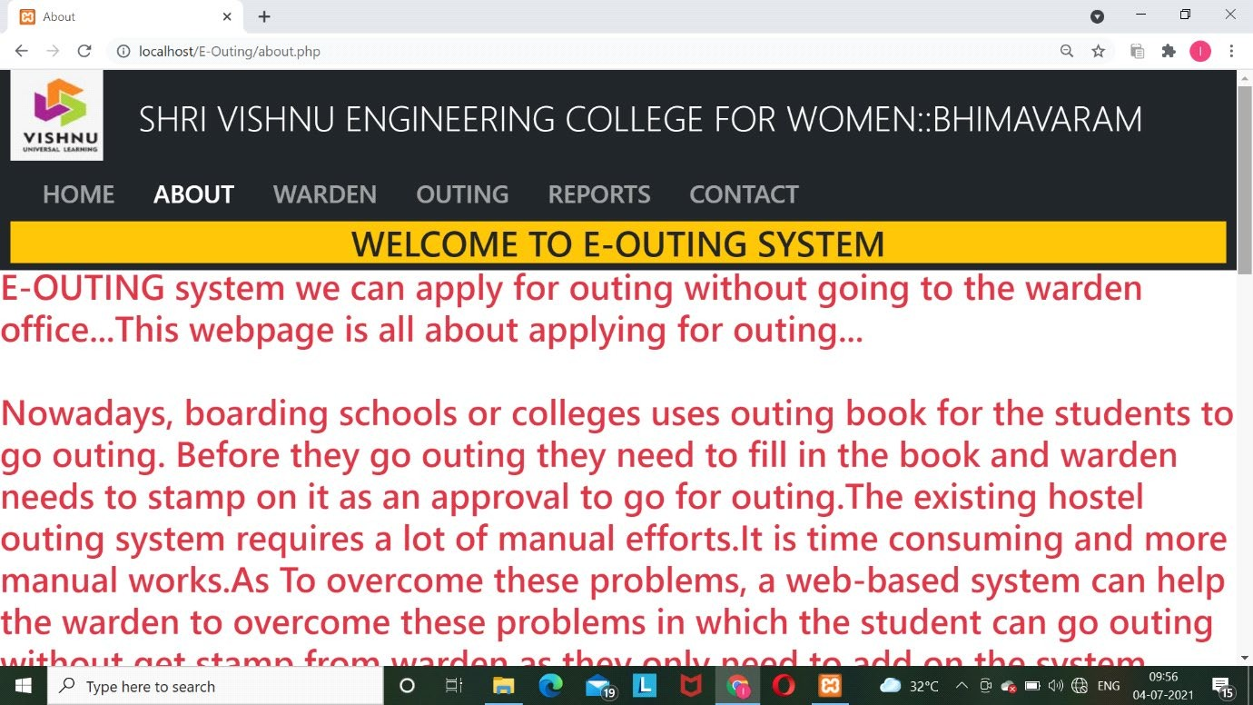

***Fig 3.2: About Page***

Figure 3.2 Shows about module in which it has information about this website.

# WARDEN

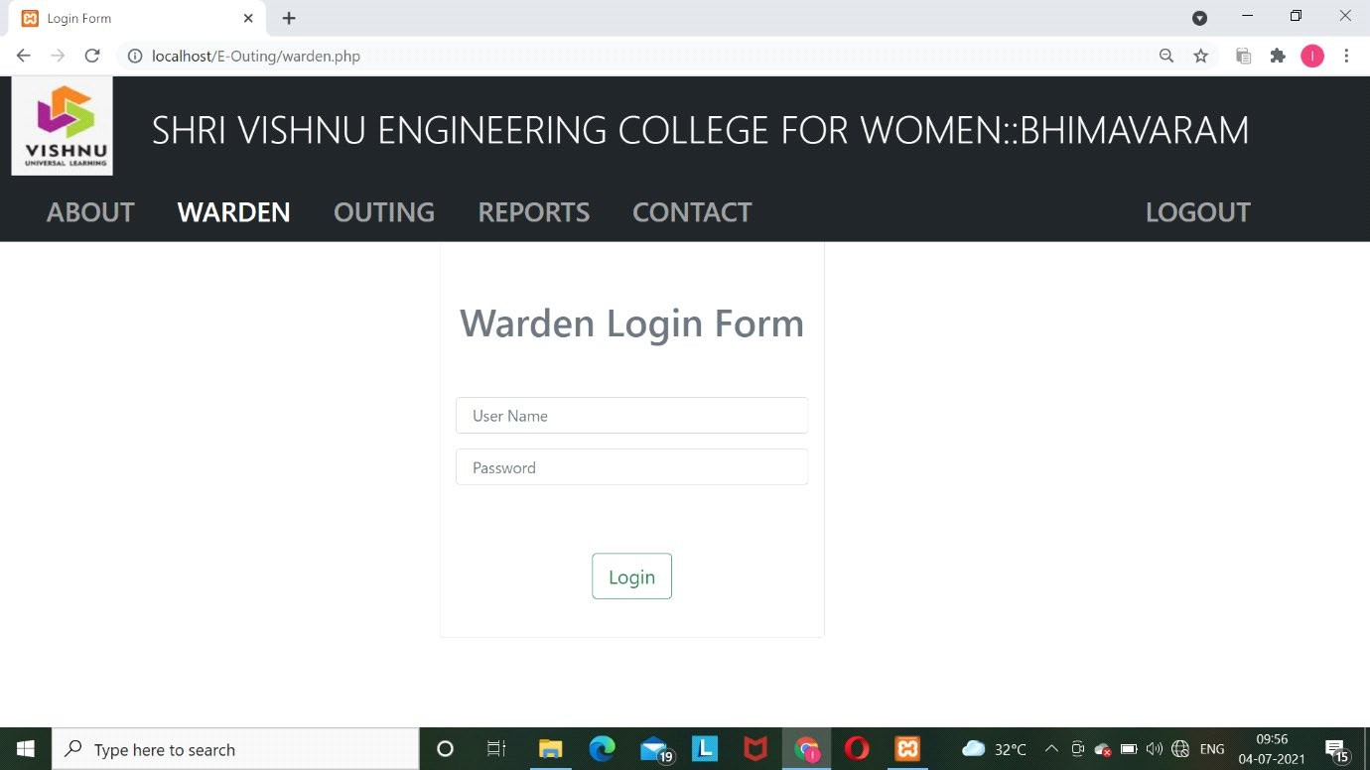

* + 1. **Apply Outing**

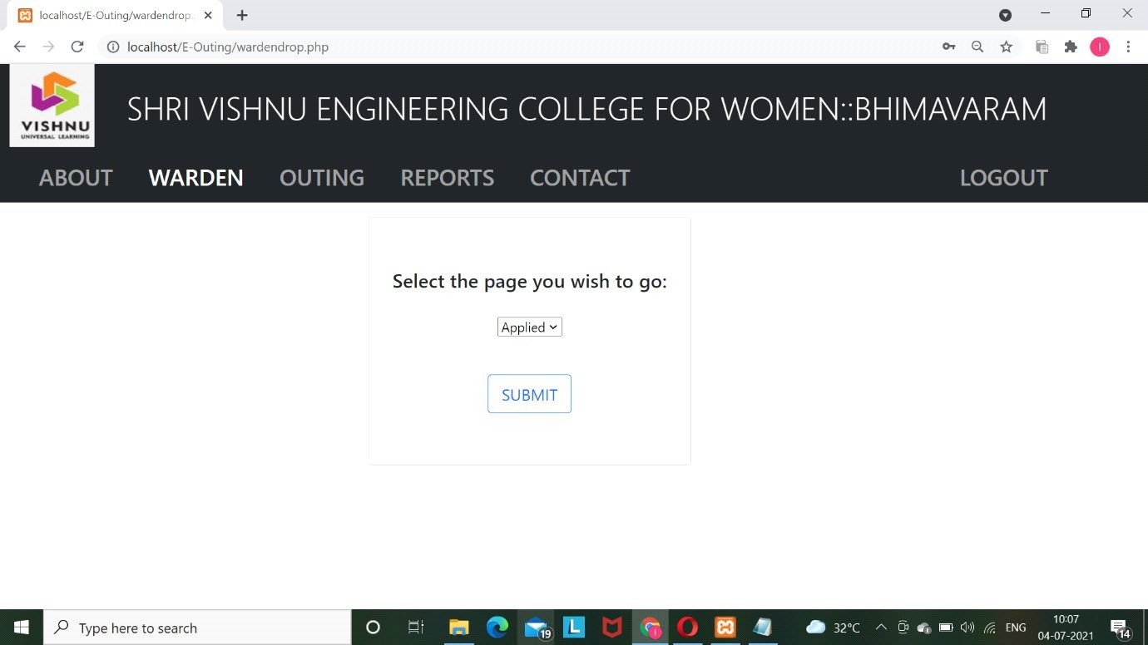

***Fig3.3: Applied Module***

Figure 3.3 Shows that warden login. In warden login there are two options one is applied. In applied module there are the requests who are in processing.

# USER DETAILS

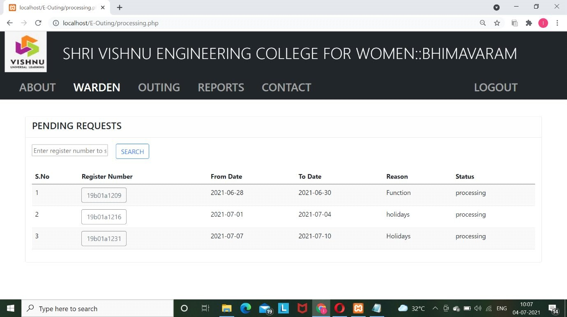

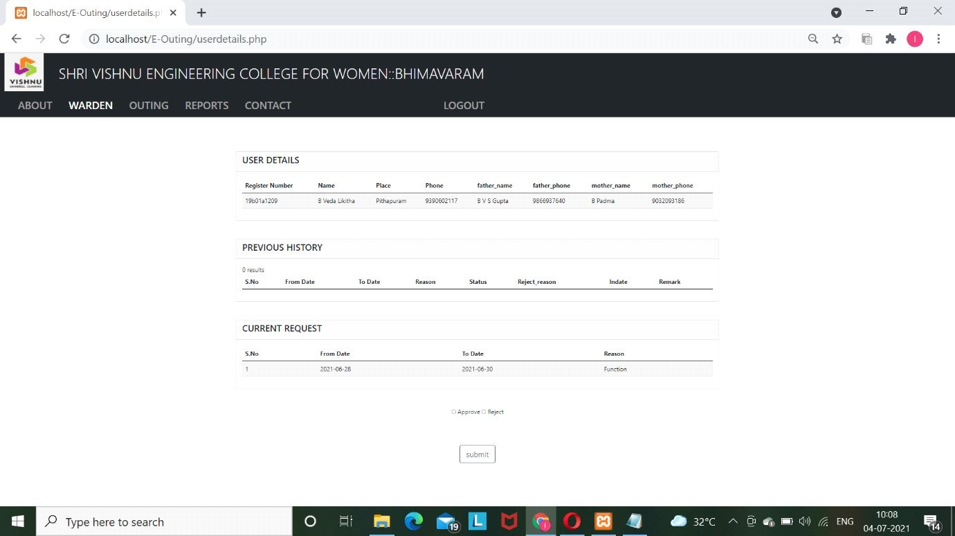

***Fig 3.4: User Details Page***

Figure 3.4 Shows that In this user details we can see the processing requests by clicking on the register number warden can see the student details and previous history and current processing data and here warden can approve or reject the student’s request.

# Return

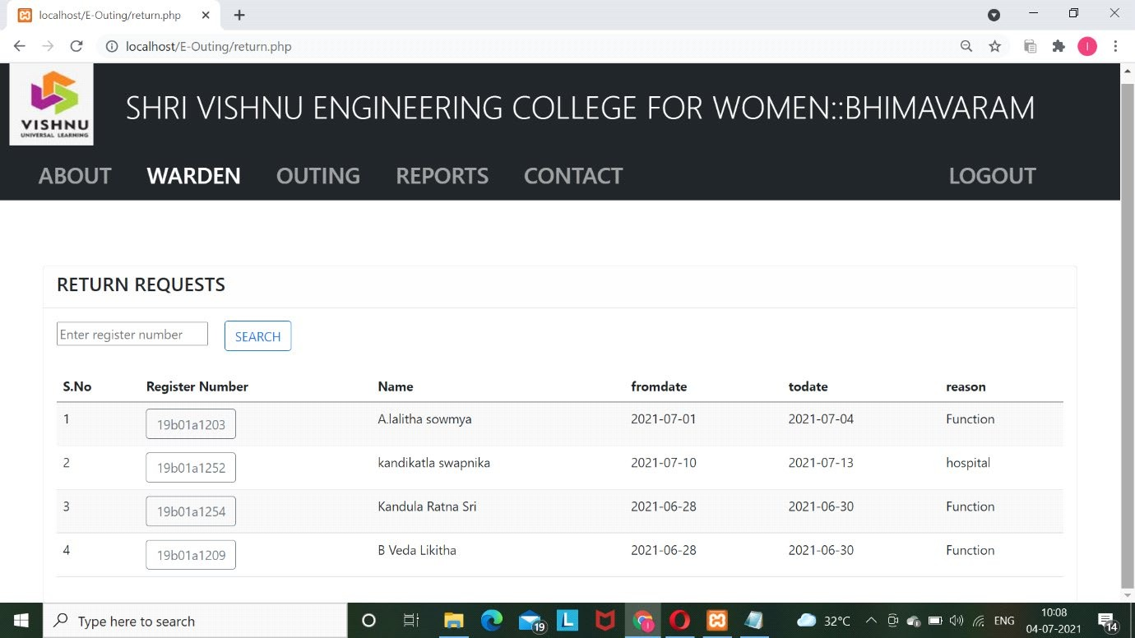

***Fig 3.5: Return Requests Page***

Figure 3.5 Shows that when the student went for outing if their request has approved. When they returned to the college then the warden will enter the return date.

# IN DATE

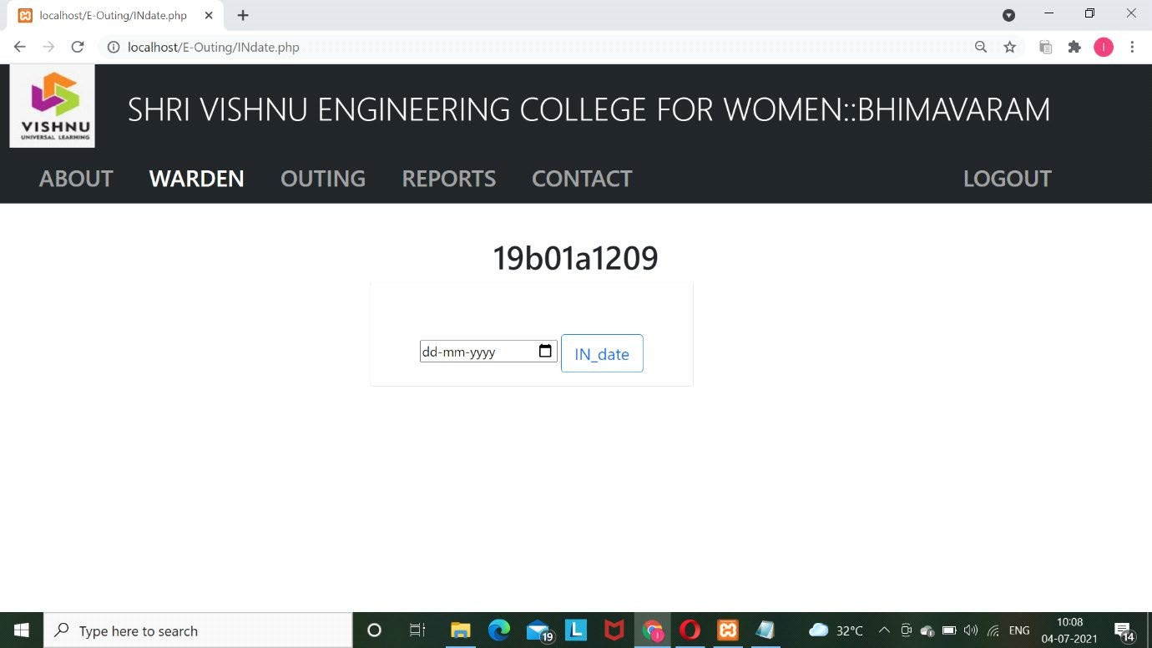

***Fig 3.6: In Date Page***

Figure 3.6 Shows that the warden enters the return date for the students.

# OUTING

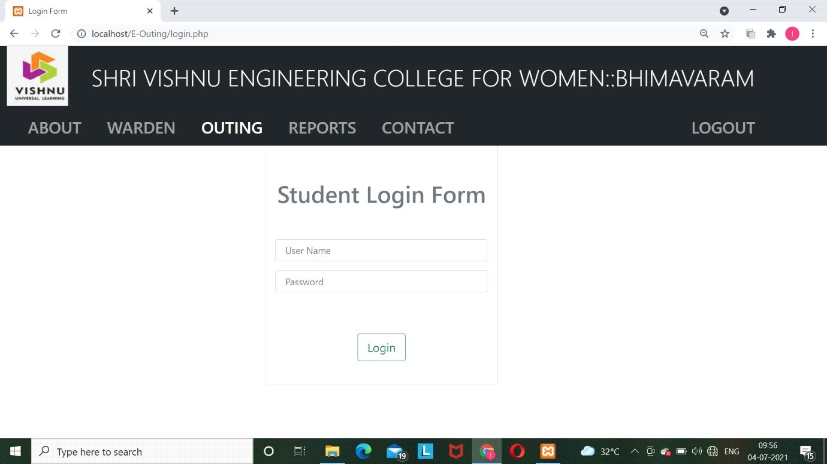

***Fig 3.7: Student Login page***

Figure 3.7 Shows that student login when student login is successful then there are two options one is outing and another one is status check.

# APPLIYING FOR OUTING

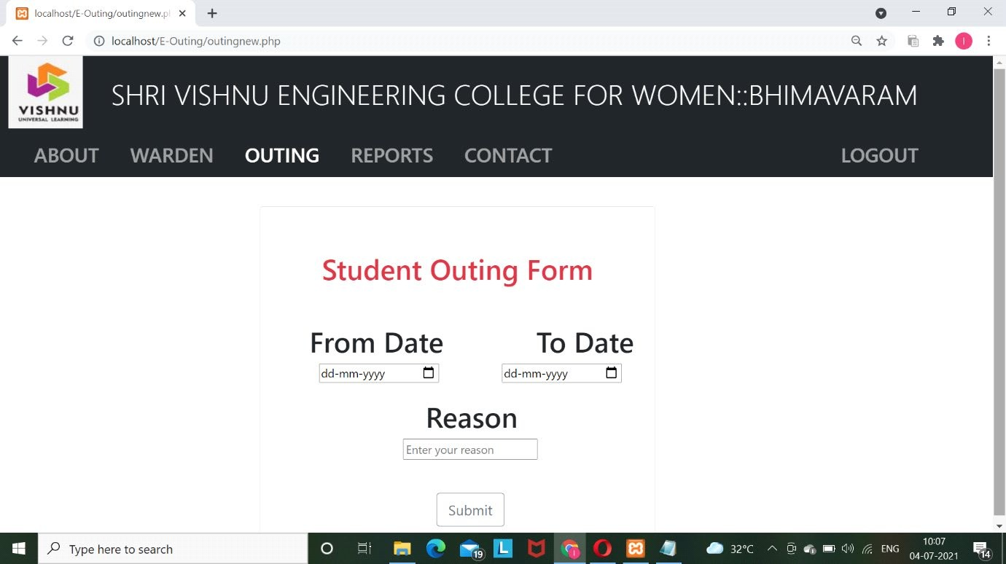

***Fig 3.8: Outing Form***

Figure 3.8 Shows that the student can apply their outing by logging in.

# STATUS CHECK

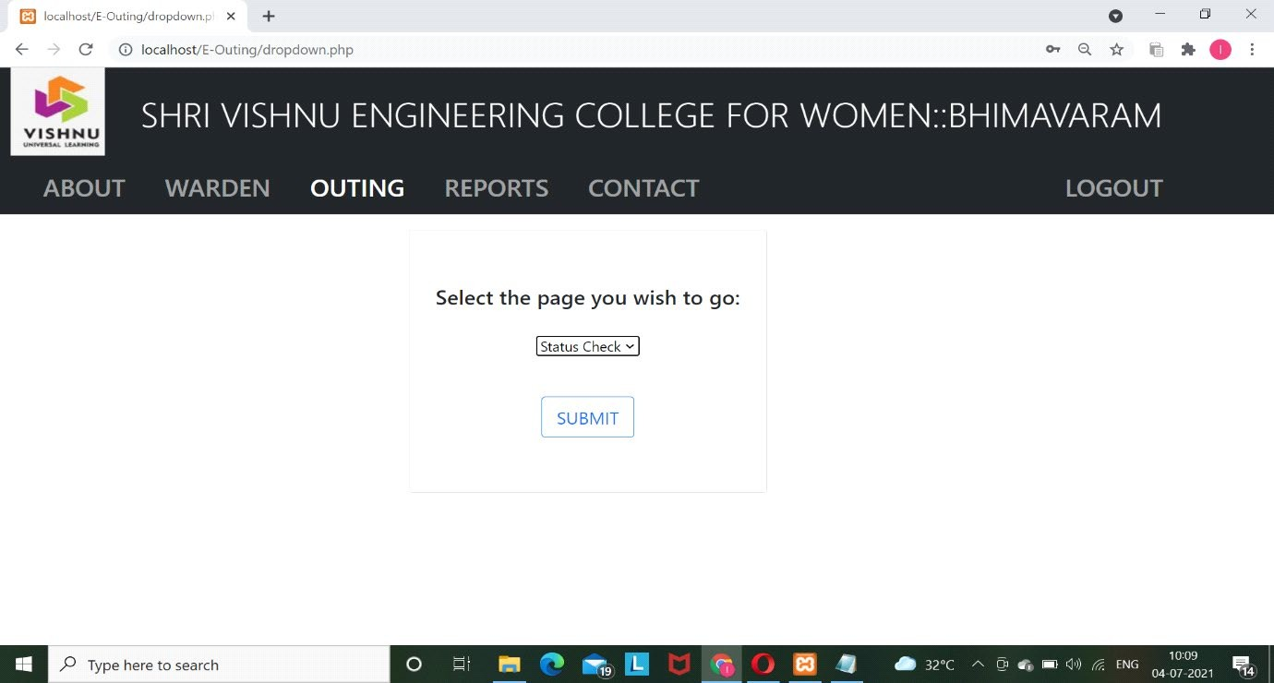

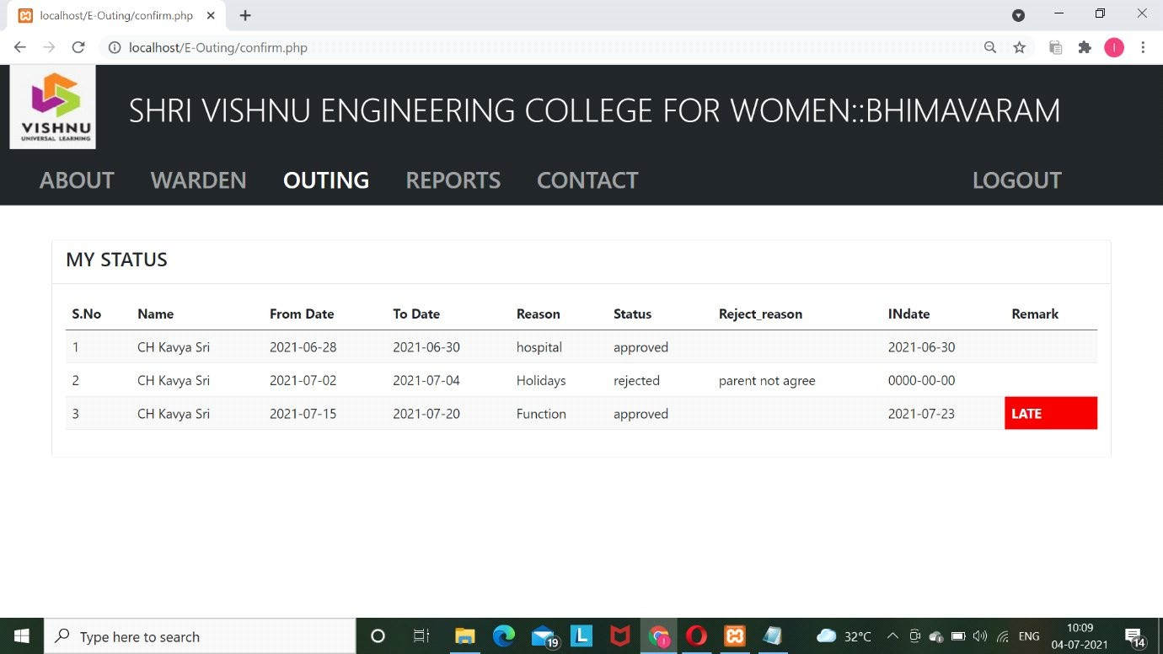

***Fig 3.9: Status Check***

Figure 3.9 Shows that status check option that the student can check the outing request status i.e approved or rejected.

# REPORTS

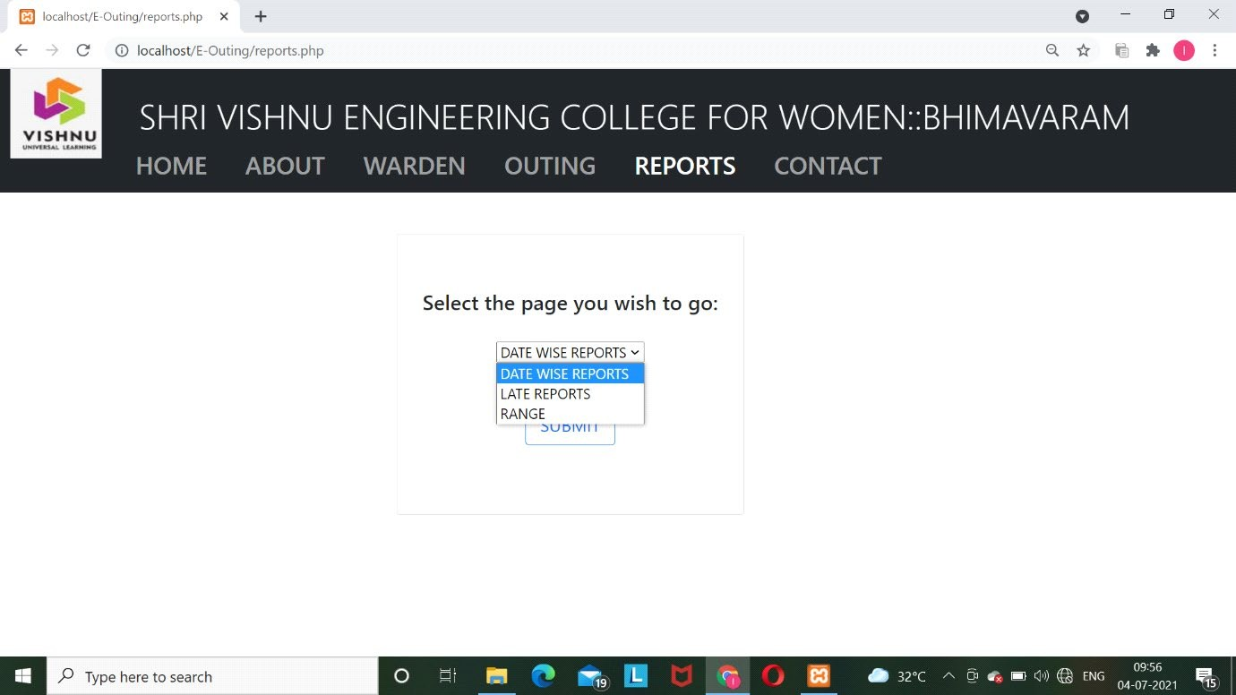

***Fig 3.10: Reports Page***

Figure 3.10 Shows that student outing reports. When we click the reports then it shows three options, they are date wise reports, late reports and range reports.

# DATEWISE REPORTS

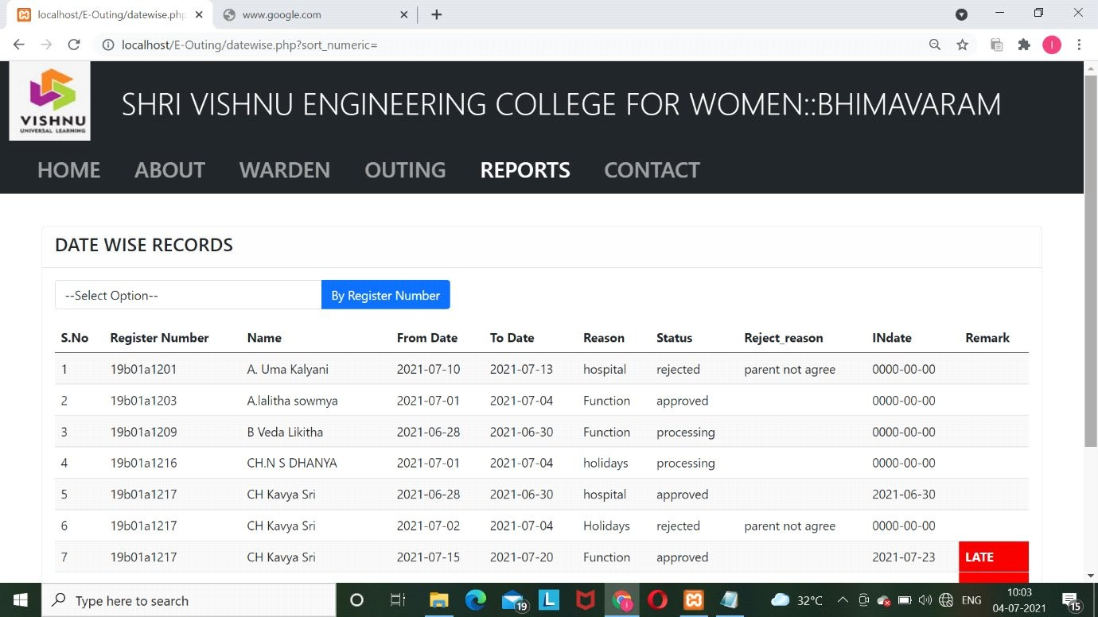

***Fig 3.11: Date Wise Reports***

Figure 3.11 In Date Wise reports we can see the whole data who applied for the outing in date wise.

# LATE REPORTS

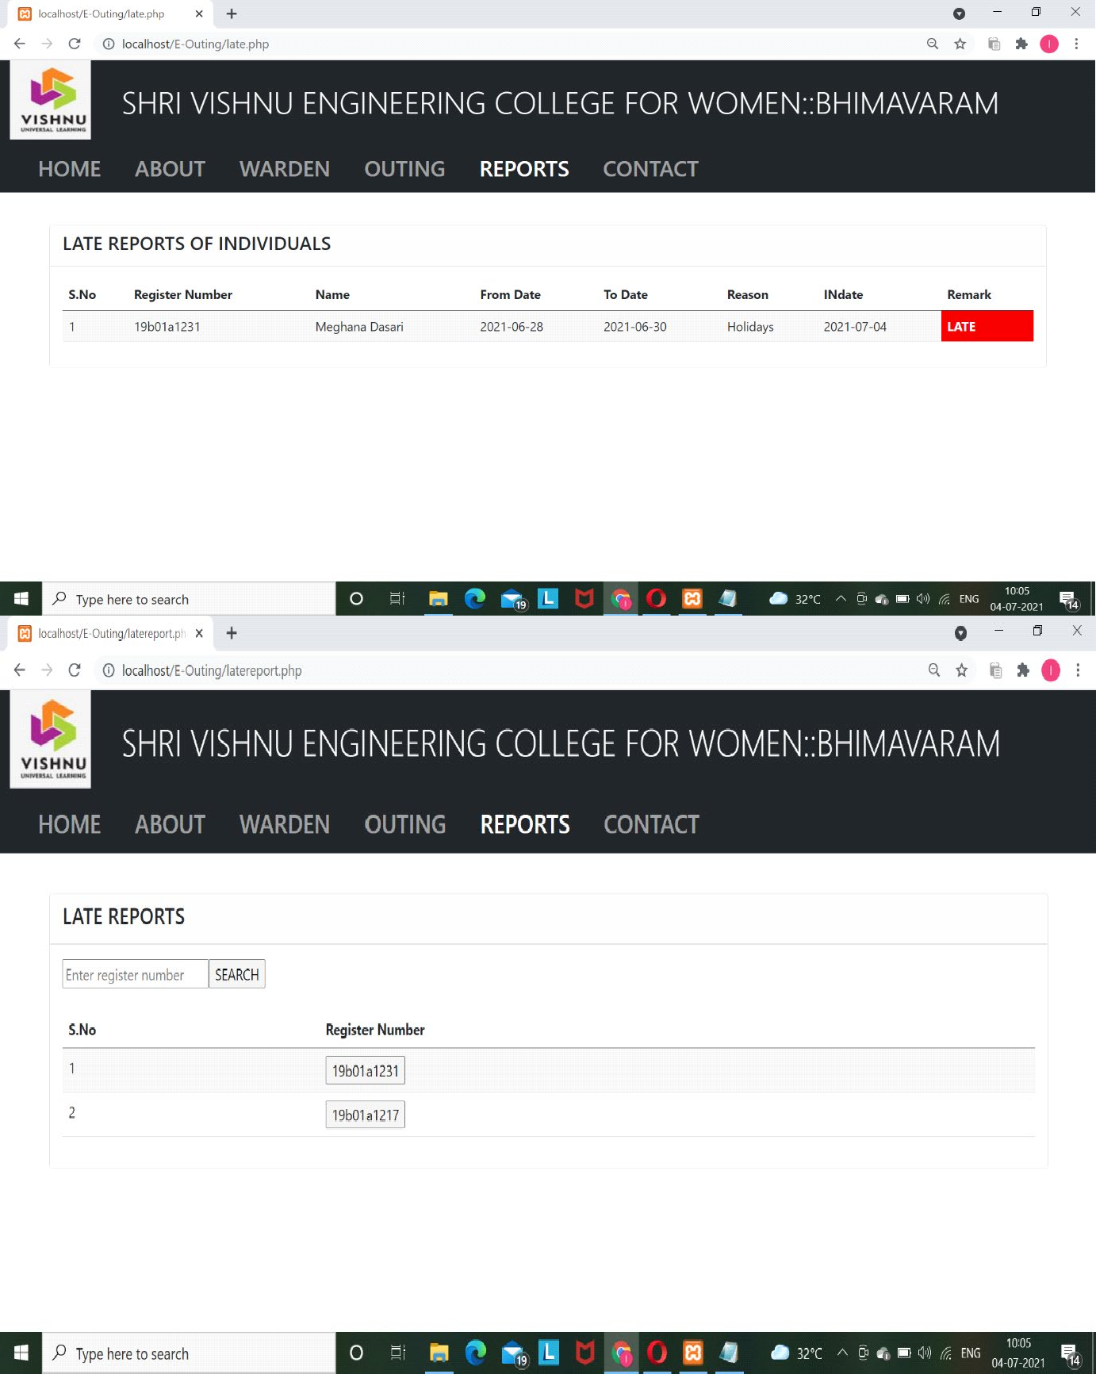

***Fig 3.12: Late Reports***

Figure 3.12 In late reports we can see the reports of the students who came late to the college that means Indate exceeds than todate.

# RANGE REPORTS

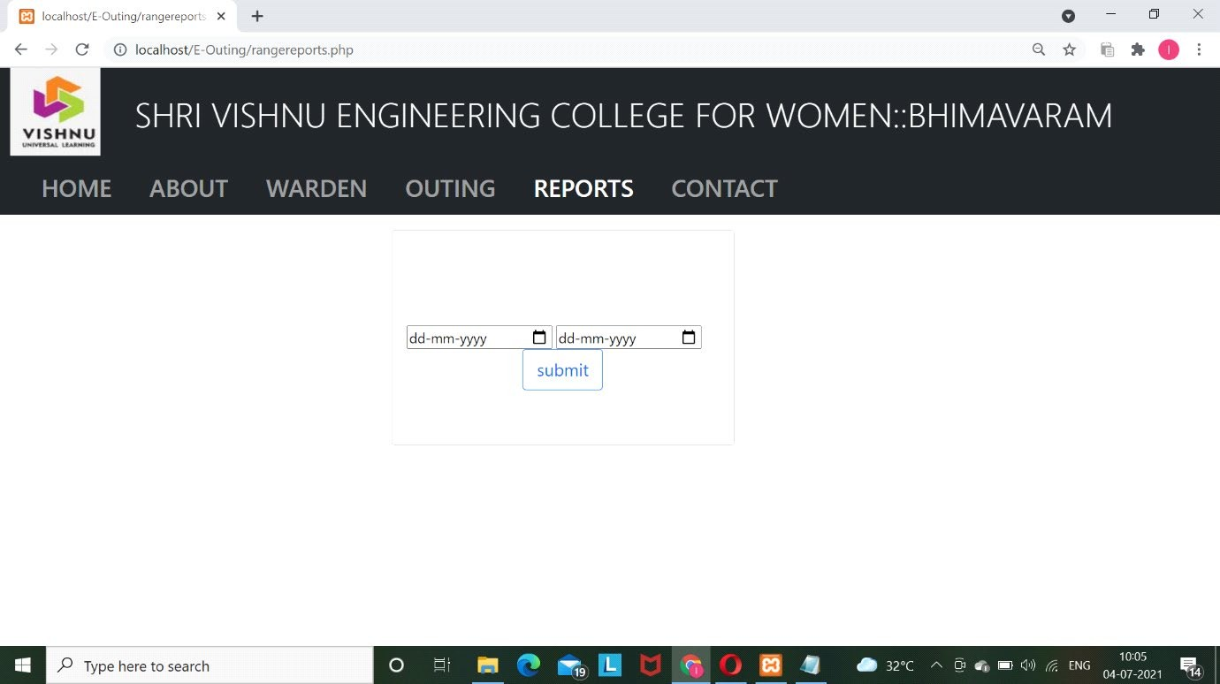

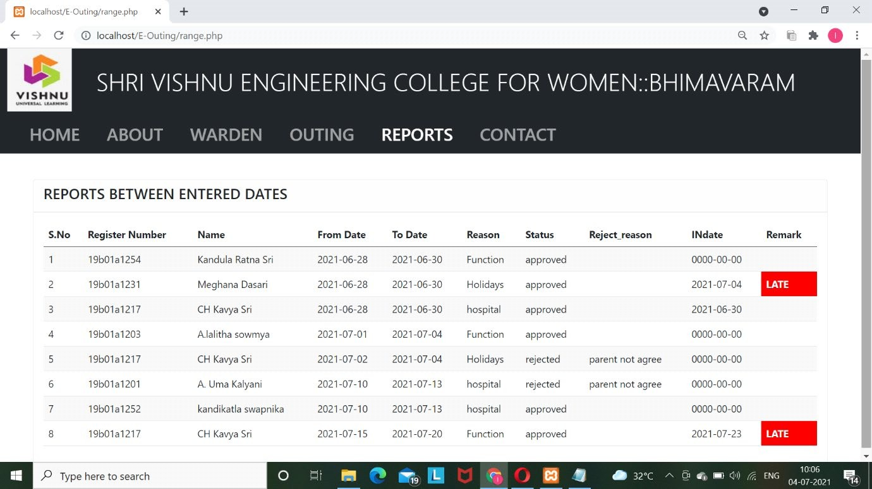

***Fig 3.13: Range Reports***

Figure 3.13 In range reports we can see the reports between two dates that we want to report.

# CONTACT

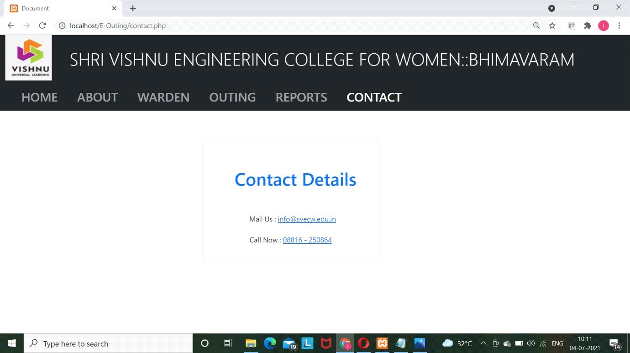

***Fig 3.14: Contact Details***

Figure 3.14 shows the contacts of the college like mail and phone numbers.If any of the student face problems then they can contact to those given mail and phone number.

# Conclusion

The interface and user manual described the functions and the flow of the system. User will be able to use the system properly if they follow the user manual.

# CHAPTER 4

**CONCLUSION**

# INTRODUCTION

This chapter focused on project contribution, constraints of the project and its conclusion, future works that can be gained from this project. From this project, we can find out how to improve the system.

# FUTURE SCOPE

In the future, there are still a lot work can be made into this system. Firstly, for the risk network, the paginations should be done to make friendly viewed by user. When a student adds their outing activity, warden and their parent will get a notify about there are student that going to outing. Then, the warden will approve immediately as they know from the notification to confirm the request outing from the student.

# CONCLUSION

As conclusion, this system has been implemented by using PHP and MYSQL. The user can use this system because this system already achieved its objectives. However, the student still need refer to warden if any change in system happens. This system is built to help student and warden in manage outing activity in efficient way.

# References

* + - Robin Nixon, “Learning PHP, MySQL & JavaScript With jQuery , CSS & HTML5”, Fourth Edition, Published by O’Reilly Media, December 2014
    - <https://www.apachefriends.org/download.html>
    - <https://developers.google.com/maps/documentation/embed/embedding>-map
    - <https://getbootstrap.com/docs/4.0/components/buttons/>
    - <https://getbootstrap.com/docs/4.0/components/card/>